Genesis 13-15 - 1.5

Abram and Lot Separate
13 So Abram went up from Egypt to the Negev, with his wife and everything he had, and Lot went with him. ² Abram had become very wealthy in livestock and in silver and gold.
(NOTES - People started using money – silver and gold – as a medium of exchange in Abram’s time – approx. 2000 BC)

³ From the Negev he went from place to place until he came to Bethel, to the place between Bethel and Ai where his tent had been earlier ⁴ and where he had first built an altar. There Abram called on the name of the Lord. ⁵ Now Lot, who was moving about with Abram, also had flocks and herds and tents. ⁶ But the land could not support them while they stayed together, for their possessions were so great that they were not able to stay together. ⁷ And quarreling arose between Abram’s herders and Lot’s. The Canaanites and Perizzites were also living in the land at that time. ⁸ So Abram said to Lot, “Let’s not have any quarreling between you and me, or between your herders and mine, for we are close relatives. ⁹ Is not the whole land before you? Let’s part company. If you go to the left, I’ll go to the right; if you go to the right, I’ll go to the left.” ¹⁰ Lot looked around and saw that the whole plain of the Jordan toward Zoar was well watered, like the garden of the Lord, like the land of Egypt. (This was before the Lord destroyed Sodom and Gomorrah.) ¹¹ So Lot chose for himself the whole plain of the Jordan and set out toward the east. The two men parted company: ¹² Abram lived in the land of Canaan, while Lot lived among the cities of the plain and pitched his tents near Sodom. ¹³ Now the people of Sodom were wicked and were sinning greatly against the Lord.
¹⁴ The Lord said to Abram after Lot had parted from him, “Look around from where you are, to the north and south, to the east and west. ¹⁵ All the land that you see I will give to you and your offspring forever. ¹⁶ I will make your offspring like the dust of the earth, so that if anyone could count the dust, then your offspring could be counted. ¹⁷ Go, walk through the length and breadth of the land, for I am giving it to you.” ¹⁸ So Abram went to live near the great trees of Mamre at Hebron, where he pitched his tents. There he built an altar to the Lord.

Abram Rescues Lot
14 At the time when Amraphel was king of Shinar, Arioch king of Ellasar, Kedorlaomer king of Elam and Tidal king of Goyim, ² these kings went to war against Bera king of Sodom, Birsha king of Gomorrah, Shinab king of Admah, Shemeber king of Zeboyim, and the king of Bela (that is, Zoar). ³ All these latter kings joined forces in the Valley of Siddim (that is, the Dead Sea Valley). ⁴ For twelve years they had been subject to Kedorlaomer, but in the thirteenth year they rebelled. ⁵ In the fourteenth year, Kedorlaomer and the kings allied with him went out and defeated the Rephaites in Ashteroth Karnaim, the Zuzites in Ham, the Emites in Shaveh Kiriathaim ⁶ and the Horites in the hill country of Seir, as far as El Paran near the desert. ⁷ Then they turned back and went to En Mishpat (that is, Kadesh), and they conquered the whole territory of the Amalekites, as well as the Amorites who were living in Hazezon Tamar.
⁸ Then the king of Sodom, the king of Gomorrah, the king of Admah, the king of Zeboyim and the king of Bela (that is, Zoar) marched out and drew up their battle lines in the Valley of Siddim ⁹ against Kedorlaomer king of Elam, Tidal king of Goyim, Amraphel king of Shinar and Arioch king of Ellasar - four kings against five. ¹⁰ Now the Valley of Siddim was full of tar pits, and when the kings of Sodom and Gomorrah fled, some of the men fell into them and the rest fled to the hills. ¹¹ The four kings seized all the goods of Sodom and Gomorrah and all their food; then they went away. ¹² They also carried off Abram’s nephew Lot and his possessions, since he was living in Sodom.
¹³ A man who had escaped came and reported this to Abram the Hebrew. Now Abram was living near the great trees of Mamre the Amorite, a brother of Eshkol and Aner, all of whom were allied with Abram.¹⁴ When Abram heard that his relative had been taken captive, he called out the 318 trained men born in his household and went in pursuit as far as Dan. ¹⁵ During the night Abram divided his men to attack them and he routed them, pursuing them as far as Hobah, north of Damascus.¹⁶ He recovered all the goods and brought back his relative Lot and his possessions, together with the women and the other people. ¹⁷ After Abram returned from defeating Kedorlaomer and the kings allied with him, the king of Sodom came out to meet him in the Valley of Shaveh (that is, the King’s Valley).
¹⁸ Then Melchizedek king of Salem (means peace) brought out bread and wine. (foreshadow of Jesus being our bread and wine). He was priest of God Most High, ¹⁹ and he blessed Abram, saying, “Blessed be Abram by God Most High, Creator of heaven and earth. ²⁰ And praise be to God Most High, who delivered your enemies into your hand.” Then Abram gave him a tenth of everything.
(NOTES -remember 10 is perfect order and what God instituted from the beginning. We still should give a tenth of the first and best of our gross income to the Lord.)

²¹ The king of Sodom said to Abram, “Give me the people and keep the goods for yourself.” ²² But Abram said to the king of Sodom, “With raised hand I have sworn an oath to the Lord, God Most High, Creator of heaven and earth, ²³ that I will accept nothing belonging to you, not even a thread or the strap of a sandal, so that you will never be able to say, ‘I made Abram rich.’ ²⁴ I will accept nothing but what my men have eaten and the share that belongs to the men who went with me - to Aner, Eshkol and Mamre. Let them have their share.”

The Lord’s Covenant With Abram
15 After this, the word of the Lord came to Abram in a vision: “Do not be afraid, Abram. I am your shield, your very great reward.”
² But Abram said, “Sovereign Lord, what can you give me since I remain childless and the one who will inherit my estate is Eliezer of Damascus?” ³ And Abram said, “You have given me no children; so a servant in my household will be my heir.” ⁴ Then the word of the Lord came to him: “This man will not be your heir, but a son who is your own flesh and blood will be your heir.” ⁵ He took him outside and said, “Look up at the sky and count the stars - if indeed you can count them.” Then he said to him, “So shall your offspring be.” ⁶ Abram believed the Lord, and he credited it to him as righteousness.
⁷ He also said to him, “I am the Lord, who brought you out of Ur of the Chaldeans to give you this land to take possession of it.” ⁸ But Abram said, “Sovereign Lord, how can I know that I will gain possession of it?” ⁹ So the Lord said to him, “Bring me a heifer, a goat and a ram, each three years old, along with a dove and a young pigeon.” ¹⁰ Abram brought all these to him, cut them in two and arranged the halves opposite each other; the birds, however, he did not cut in half.¹¹ Then birds of prey came down on the carcasses, but Abram drove them away. ¹² As the sun was setting, Abram fell into a deep sleep, and a thick and dreadful darkness came over him. ¹³ Then the Lord said to him, “Know for certain that for four hundred years your descendants will be strangers in a country not their own and that they will be enslaved and mistreated there. ¹⁴ But I will punish the nation they serve as slaves, and afterward they will come out with great possessions. ¹⁵ You, however, will go to your ancestors in peace and be buried at a good old age. ¹⁶ In the fourth generation your descendants will come back here, for the sin of the Amorites has not yet reached its full measure.”
¹⁷ When the sun had set and darkness had fallen, a smoking firepot with a blazing torch appeared and passed between the pieces. ¹⁸ On that day the Lord made a covenant with Abram and said, “To your descendants I give this land, from the Wadi of Egypt to the great river, the Euphrates - ¹⁹ the land of the Kenites, Kenizzites, Kadmonites, ²⁰ Hittites, Perizzites, Rephaites, ²¹ Amorites, Canaanites, Girgashites and Jebusites.” (see map below of these boundaries)

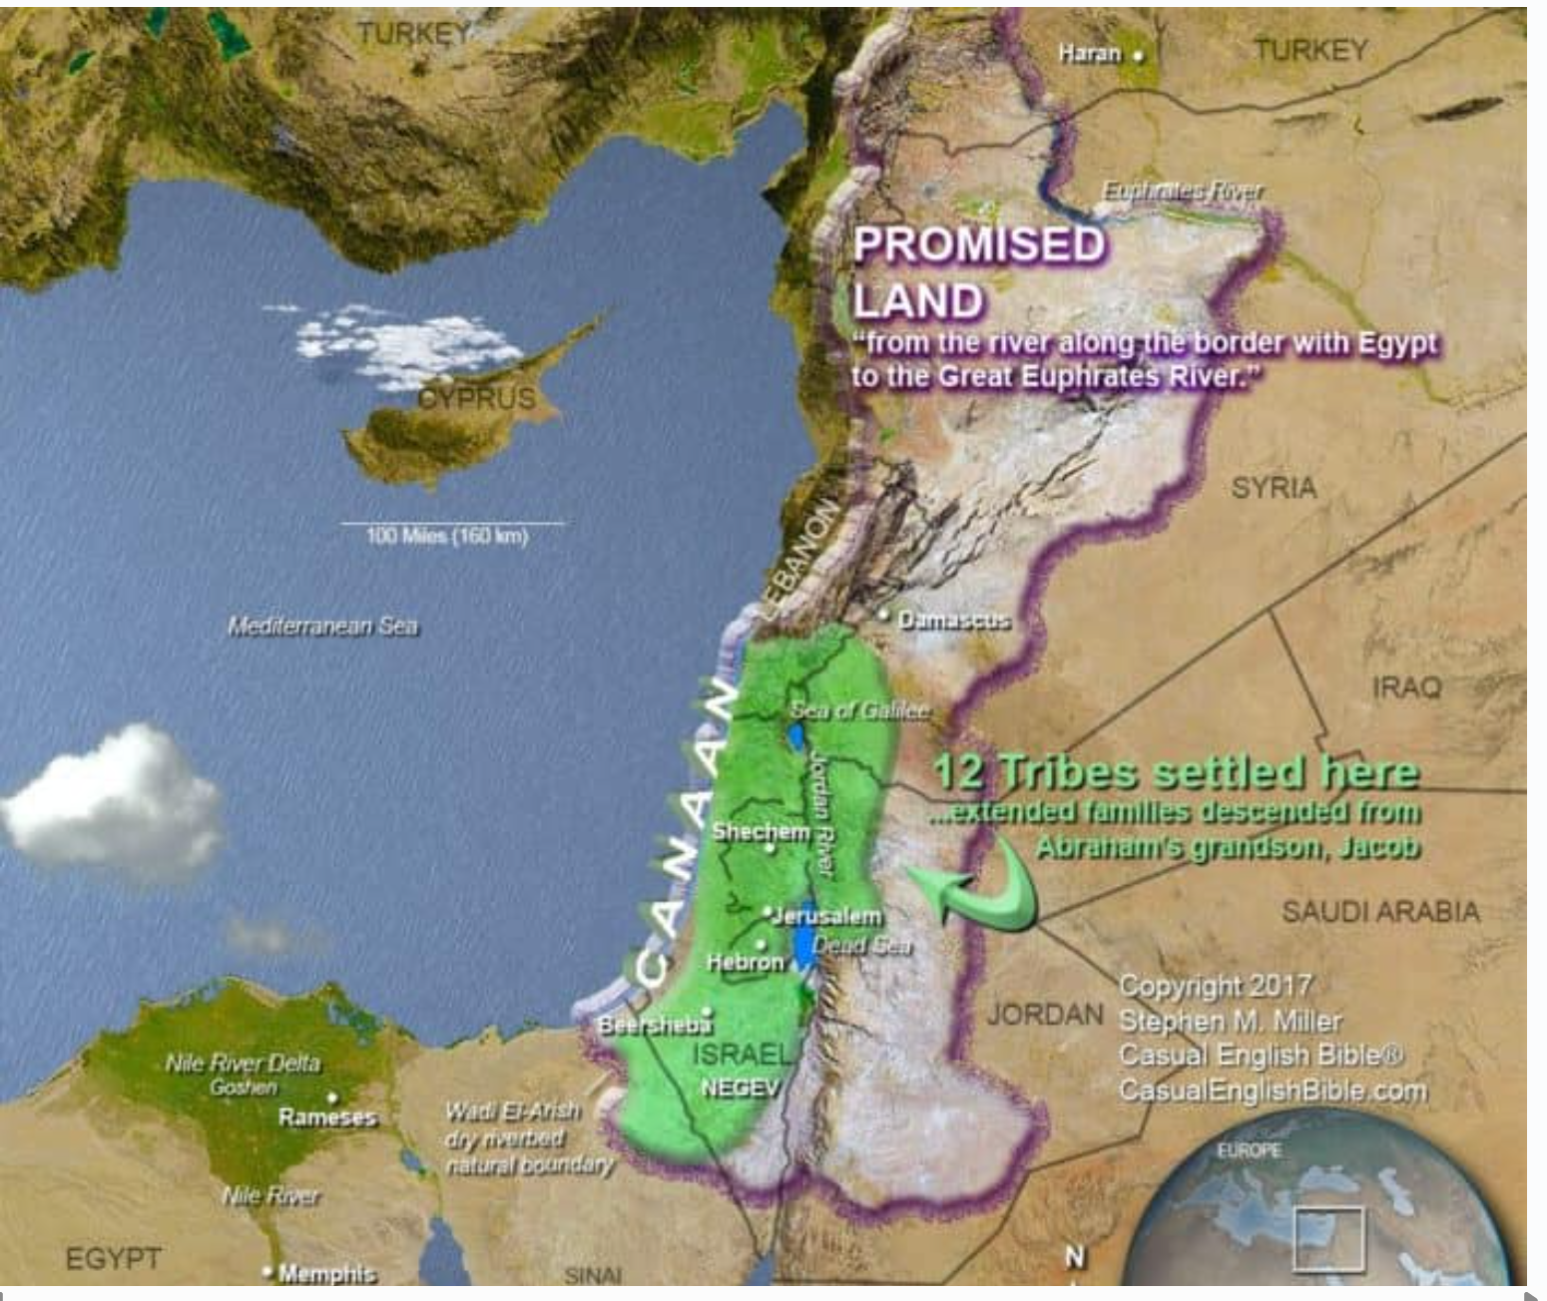

Answer to the significance of the 4 vs 5 Kings World war

Genesis 14 — WHY the 4 vs 5 Kings War Matters (Prophetic & Spiritual)

1. This Is the First Recorded World War
- First time Scripture records:
  - Named kings
  - Coalitions of nations
  - Economic tribute
  - Rebellion against empire
- Establishes the biblical pattern of global power blocs
- Sets the stage for all later empires (Daniel & Revelation)

2. The 4 Kings = Imperial World Power
- Led by Chedorlaomer (king of Elam)
- Elam = ancient eastern empire power
- The 4 kings:
  - Are united
  - Are aggressive
  - Demand tribute (economic control)
- Prophetic picture: centralized, beast-like authority
Pattern repeated later in:
- Daniel 2 & 7 (beast empires)
- Revelation 13 (global authority)
- Revelation 17 (kings giving power to one ruler)

3. The 5 Kings = Fragmented Earthly Rule
- Kings of Sodom, Gomorrah, Admah, Zeboiim, Zoar
- Represent:
  - City-states
  - Moral corruption
  - Political weakness
- They serve for 12 years, then rebel in the 13th
Spiritual insight:
- Earthly systems rebel against tyranny
- But rebellion without God fails

4. 4 vs 5 = Authority vs Humanity
- 4 in Scripture:
  - Earth (4 directions)
  - World systems
  - Dominion structures
- 5 in Scripture:
  - Humanity
  - Responsibility
  - Weakness without grace
Prophetic tension:
- World power dominates fallen humanity
- Humanity cannot overthrow beast systems on its own

5. The War Targets the Seed Line
- Lot (Abram’s relative) is taken captive
- Satan’s pattern:
  - Attack the righteous through proximity to wicked systems
- This mirrors:
  - Egypt enslaving Israel
  - Babylon exiling Judah
  - End-time persecution of saints

6. Abram = The Hidden Kingdom of God
- Abram is not a king
- Has:
  - No throne
  - No army state
  - No empire
- Yet:
  - He defeats the 4 kings
  - With 318 trained servants
- God’s kingdom operates outside worldly power structures
Foreshadowing:
- Gideon
- David
- Jesus
- The remnant church

7. Melchizedek Appears Immediately After
- King of Salem = King of Peace
- Priest of the Most High God
- Blesses Abram before Abram gives the tithe
This tells us:
- The war exists to introduce Melchizedek
- Melchizedek = eternal priesthood
- Points directly to Christ (Psalm 110, Hebrews 7)

8. Refusal of Sodom’s Wealth = Prophetic Separation
- King of Sodom offers reward
- Abram refuses:
  - “Lest you say, ‘I made Abram rich’”
- Spiritual principle:
  - God’s people do not prosper by beast systems
  - Wealth from corrupt power defiles witness

9. End-Time Parallel (Very Important)
Genesis 14 prefigures:
- Coalition of kings (Rev 16–17)
- Economic tribute and control (Rev 13)
- Captivity of saints
- Deliverance by God alone
- Appearance of Christ as eternal King-Priest

10. The Core Prophetic Message
- World empires rise and fall
- Human rebellion fails without God
- God’s covenant people are targeted
- Deliverance comes from outside the system
- Jesus reigns as King AND Priest
- The righteous refuse Babylon’s rewards

One-Sentence Summary
Genesis 14 reveals that global empire will always war against God’s covenant people, but the Kingdom of God—though hidden and small—will triumph through Christ alone.

